| **Q**uick **R**eference **G**uide | **Description: Description: DZA Logo** |
| --- | --- |
| **Item Submission Form – Vendor/Broker Overview** | |

 **Starting 12/23/2013, please use the Item Submission Form for any *new item*, *shipper/module*, and *maintenance*.**

* **Only fill out fields shaded in yellow.** DO not fill out fields shaded in *blue* (Category only) or *gray* (item setup only).
* **The Item Submission Form *Version Number* is located in the upper left corner of the Form.**

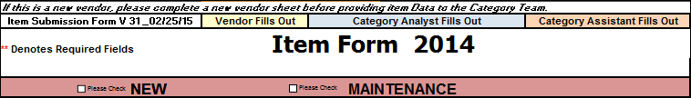

* **The latest version of the Item Submission Form can be accessed in the following ways:**
* Request the Form directly from your Category Team
* Access the Form via the Delhaize America *Business to Business* website: **http://b2bhannaford.com**

**New Item *(Item UPC is not located in Delhaize system)***

* Please fill out all fields shaded in **yellow** and **marked with asterisks** **\*\***
* **\*\* Two red asterisks denote *required* fields**
* Each field contains informational commentary:
* Hover the cursor over a particular field to display Delhaize requirements (and any additional information) pertaining to that field.

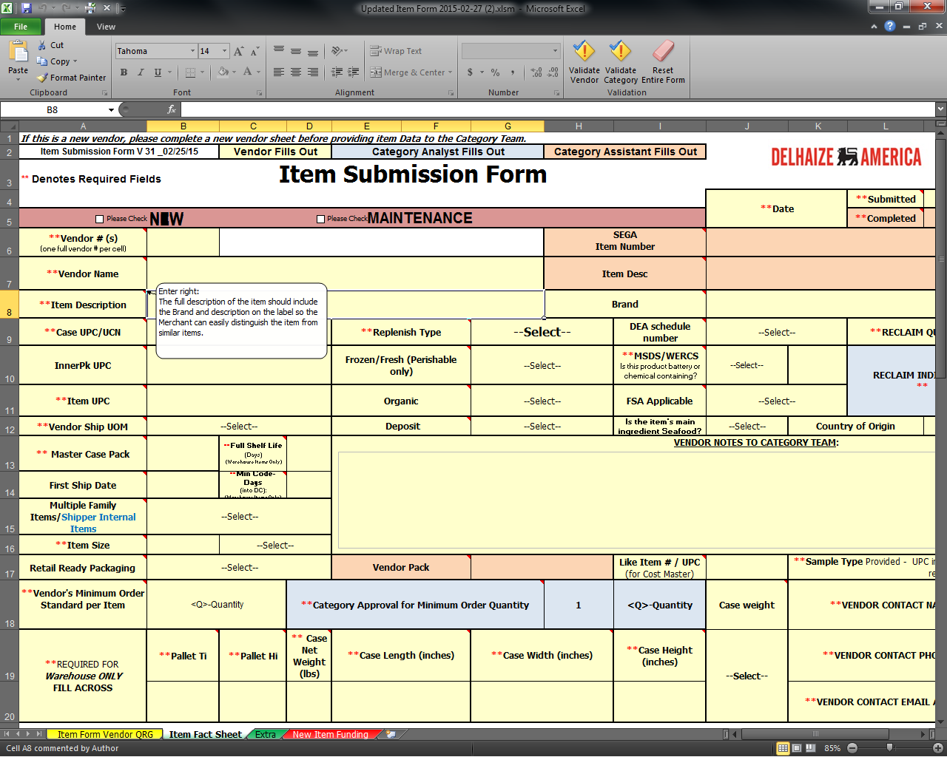

 For further information regarding specific fields on the Item Submission Form, please contact your Category Team.

* When finished completing the form, click the **Validate Vendor** button under the “Home” tab at the top of the screen.
* Clicking this button will validate that all requisite fields have been completed.

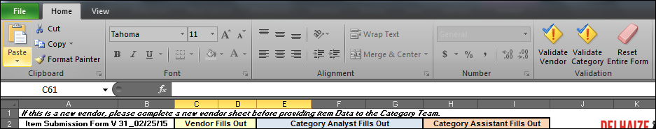

* Any fields in red must be filled out before item submission is complete.

**Item Maintenance *(Item UPC is located in Delhaize system)***

To update or make changes on an item that currently exists in the Delhaize system, please use the **Item Fact Sheet** tab.

* Click the “**Please Check**” box next to “MAINTENANCE”



* Complete the following fields, all of which are required when doing item maintenance:

|  |  |
| --- | --- |
| * **Vendor # (s)** | * **Item Description** |
| * **Vendor Name** | * **Item UPC** |

* Fill out any information requiring changes and provide any relevant details in the **Vendor Notes to Category Team** field.
* For example, if the Vendor wants to change the pack size on an item, they might key:

*“Our vendor pack is changing from 4 to 1 on item# 123451, UPC 1234567890. Effective immediately.”*

**Shipper/Pallet Setup**

* In the **Replenish Type** field, select “**Shipper/Pallet with components**”.

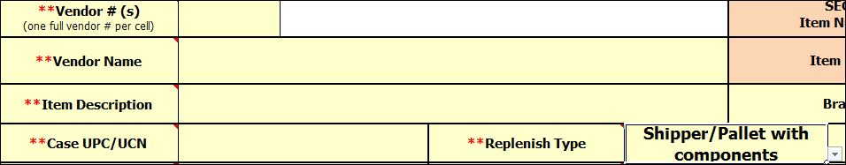

* Complete all required setup fields (marked with asterisks **\*\***)
* Click the **Multi Item or** **Display Component** tab, and fill out all necessary information for component setup (I.e. Item UPC, UCN of additional items, Item Description, Quantity, Unit SEGA Cost, Unit SEGA Deal Cost [if applicable], Size, and Unit of Measure.)



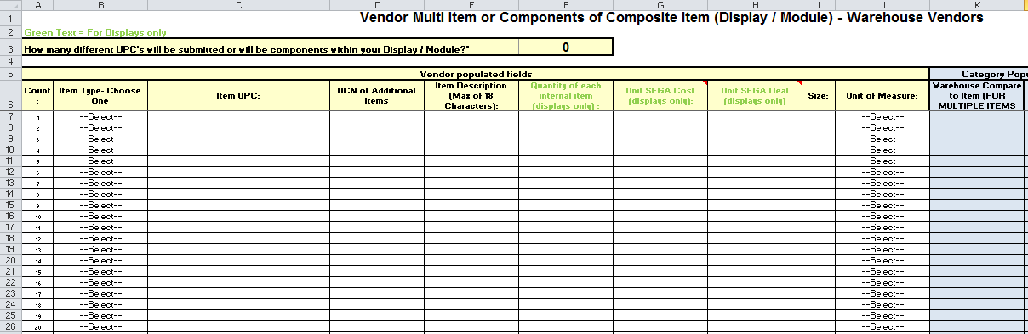

**Notes**

* If there are multiple new items with the *same* Ti/Hi and case dimensions, a single form may be used for these items:
* In the **Multiple Family Items/Shipper Internal Items** field (Row 15 of the Item Submission Form), select “**Additional Family Item**”.

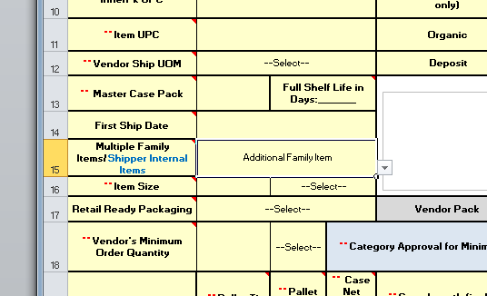

* Then, input all required item information on the **Multi Item or Display Component** tab.



* To communicate additional item setup or maintenance information (e.g. store authorization listing, scannable UPC, item image, etc.), utilize the **Extra** tab.



 **The Item Submission Form tabs cannot be changed, nor can additional tabs be added.** If further information must be communicated (beyond the “Extra” tab), please send that information in a *separate* Excel workbook.